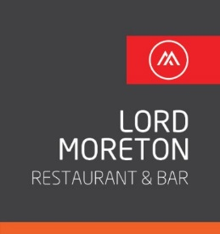

Lord Moreton Sunday Lunch

STARTERS £3.30

Chefs Homemade soup of the day with warm bread
Prawn Cocktail
Chicken Liver Pate

MAIN COURSE £10.50

Lord Moreton Roast Carvery Beef, Turkey or Pork
Yorkshire Puddings & all the trimmings.
Mushrooms with leek,pear spinach& walnut
stuffing
With veg of the day & gravy (vegetarian)

DESSERTS £3.30

Please ask your server for todays selection

Complimentary tea, coffee or iced water (near the dessert display fridge

